BRETT’S Beds & Futons Chests of Drawers Price List 2014
brettsfutons.com.au | info@brettsfutons.com.au (08) 9209 2730, 21 Mulgul Road, Malaga, WA 6090

Standard Drawers (16 cm)
 | THICK PROFILE – 30mm  4 Standard Drawers  Jarrah $1295  Marri/Tassie $1555 |  | THIN PROFILE – 15mm  4 Standard Drawers  Jarrah $995  Marri/Tassie $1195
 | THICK PROFILE – 30mm  5 Standard Drawers  Jarrah $1495  Marri/Tassie $1795 | 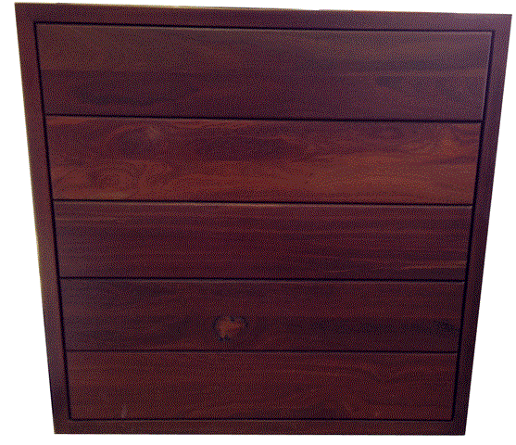 | THIN PROFILE – 15mm  5 Standard Drawers  Jarrah $1195  Marri/Tassie $1435

Deep Drawers (20 cm)
 | THICK PROFILE – 30mm  4 Deep Drawers  Jarrah $1495  Marri/Tassie $1795 |  | THIN PROFILE – 15mm  4 Deep Drawers  Jarrah $1195  Marri/Tassie $1435
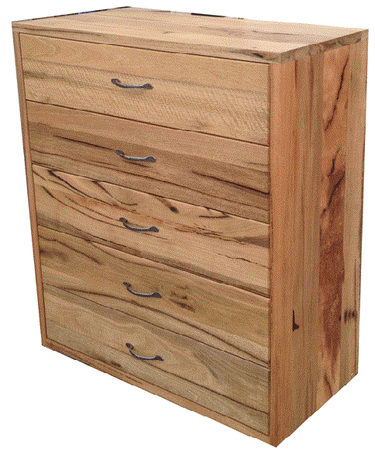 | THICK PROFILE – 30mm  5 Deep Drawers  Jarrah $1695  Marri/Tassie $2035 |  | THIN PROFILE – 15mm  5 Deep Drawers  Jarrah $1395  Marri/Tassie $1675

Extra Drawer - $200
Split Drawer - $200
Push Runners on drawers are extra $250 per Chest of Drawers
Stained drawers inside are extra $100 per Chest of Drawers

